WILDFLOWERS MISSION
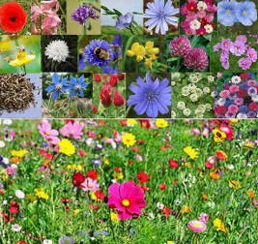
ECO TEAM 2024 – 2025
Y2 | Grace | Aazar
Y3 | Bryan | Arush
Y4 | Princeton | Aaliyah
Y5 | Leo | Zoe
Y6 | Nipuni | Nisarg

Meeting Agenda – 1/4/25
- As a group, we met to talk about our Wildflowers Mission. We dd some research into how to plant wildflowers and watched a video Mr Rabjohn found which showed how to plant, how they grow and what wildflowers are useful for.

- We all went outside to the playground and prepared the planters by weeding them and topping up the soil with fresh (peat free) compost.

- We raked the surface and watered it. We planted the wildflower seeds and finished by watering them.

- Our plan is to look at ways to protect the seeds and planters from children standing on them and picking the flowers when they start to grow.

- The eco team suggested presenting in assembly and talking to the children about how to protect these and why they are planting them as part of their mission.

- Mr Rabjohn created singed to display.

- Mrs Agbanusi to update the eco board display with new photos and updates for the missions and what’s next for the eco team.
