WILDFLOWERS MISSION
ECO TEAM 2024 – 2025
Y2 | Grace | Aazar
Y3 | Bryan | Arush
Y4 | Princeton | Aaliyah
Y5 | Leo | Zoe
Y6 | Nipuni | Nisarg

Meeting Agenda – 4 /4/25
Session 2
The eco team and staff continued this activity in the junior playground.
They have two more planters in there.
We recalled how we planted the previous wildflowers in Kaey Stage 1 and as a group
-Prepared the planters, raked the soil and wet it ready for the seeds.
-The children then spreads the wildflowers seeds, raked over the soil and added some more water for the seeds to settle.
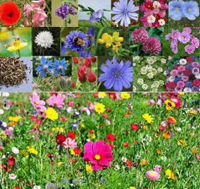

- Mr Rabjohn created singed to display.

- Mrs Agbanusi to update the eco board display with new photos and updates for the missions and what’s next for the eco team.

