


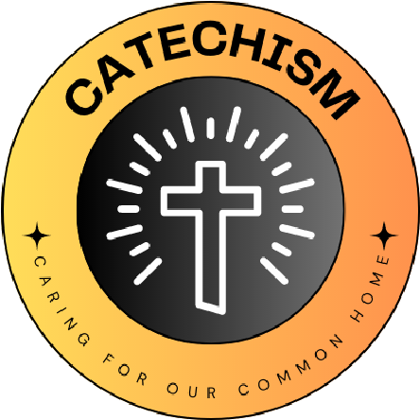

L
I
V
I
N
G

L
A
U
D
A
T
O

S
I
C
A
R
I
N
G

F
O
R

O
U
R

C
O
M
M
O
N

H
O
M
E
School name
The quote we have chosen is...

ST Hildegard of Bingen
“The Earth sustains humanity. It must not be injured: it must not be destroyed.”

We have chosen this because.....
“We have chosen this because it stood out from the other quotes to our eco warriors. It sounds like the person who wrote it wants the world to be very eco friendly and protected, like us. It tells us that the world is God’s creation and that we should be eco friendly and not hurt it. It says that we shouldn’t destroy the world because we have to look after it for God. We shouldn’t chop down trees because they give us oxygen so we need to look after that.”
What Missions and Sub-missions have you chosen and how does your 'why' link to this?
Energy
Big Switch off Campaign November 2023
We feel that we need to raise awareness of why it is important to switch off electrical items when not in use and how wasting electricity affects the planet.
Water
Global Action – We will be working with our local parish and the UOcean Project on a project to litter pick in our local waterways at Watermead. We will also raise awareness of the UOcean Project and the important work that they do to help protect our planet.
Waste
Recycling facilities – We will be working to introduce more waste recycling in our school for items such as dental equipment and snack wrappers to save this kind of waste from going to landfill and destroying our planet.
Our 'why' for the year
Bishop Ellis Catholic Voluntary Academy

