
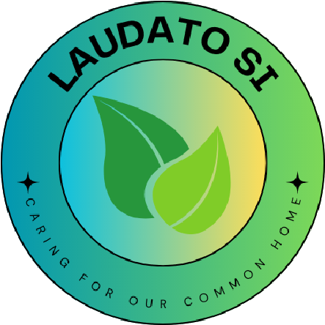
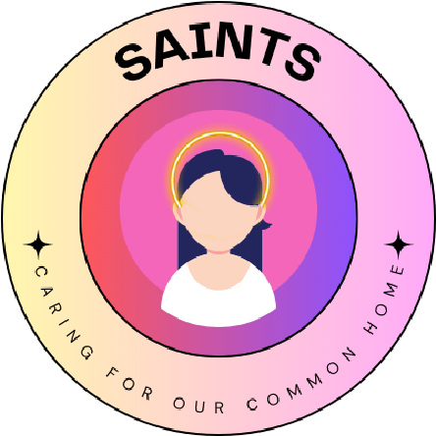
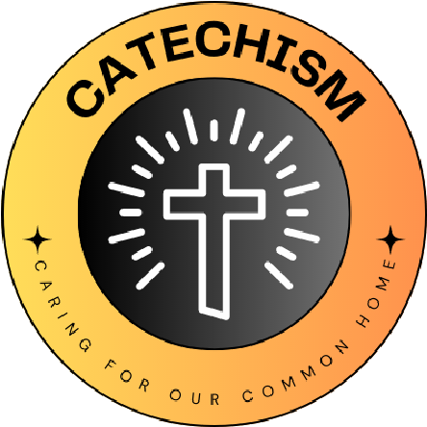
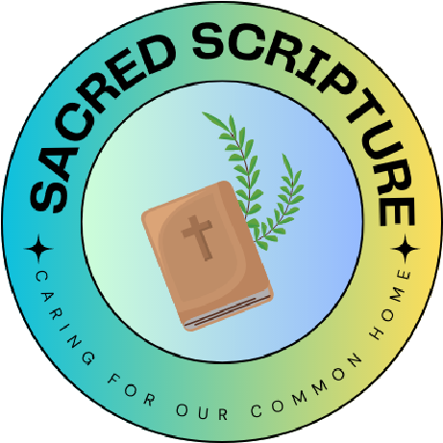
L
I
V
I
N
G

L
A
U
D
A
T
O

S
I
C
A
R
I
N
G

F
O
R

O
U
R

C
O
M
M
O
N

H
O
M
E
S
School name
Saint Mary’s

The quote we have chosen is…

‘Aspire not to have more, but to be more.’
Oscar Romero

We have chosen this because...
When we were looking for our quote, The Eco Committee wanted to choose a shorter one to get everybody’s attention. They thought it would be easier for us all to remember and if we could remember it, we would think about it all year.
This quote was perfect for us because we all thought that ‘having more’ wasn’t sustainable, but ‘being more’, as a person, is sustainable.

What Missions and Sub-missions have you chosen and how does your 'why' link to this?
We are going to focus on Nature, Waste and Travel this year.
In Nature, our sub-mission is Wildflower seeding. This links to our ‘why’ because by re-wilding our school grounds, spreading wildflowers, we are encouraging bees and other wildlife, essential to our Earth, to continue pollinating which is crucial for healthy life cycles. Our Eco Committee liked the idea of creating a ‘Prayer Garden’ and suggested scattering wildflower seeds in the Courtyard, as it’s near our Chaplaincy Area.
In Waste, our submission is Litter Picking. This links to our ‘why’ because together we can be so much more, by using our voices we can deter people in the wider community to litter, fly tip and pollute our world further. We have all the equipment to make the difference and every one of us will make a difference in our Community if we work together.
In Travel, our submission is Termly Travel Week. This links to our ’why’ because by thinking about our world, we’ll all become better people. By choosing to travel more sustainably, by walking, scooting or car sharing, we’ll reduce air pollution around our school.
Our 'why' for the year

