ECO TEAM - 2025/2026 MISSIONS
At our first Eco school meeting this year we completed our environmental review to discuss the missions we wanted to focus on in school.

Food

We are going to continue the excellent work of our previous Eco teams and build on the success of our school food pantry.
St Patrick’s Food Pantry provides much needed food for our families and the local community. Our aim this year is to build links with other schools in the trust to help source the food for the pantry, build relationships with local businesses for donations and sponsorships and to extend our welcome to the local community in accessing our food bank.

Waste
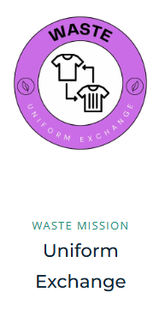
This year we are going to collect in more used uniform and pass on to our families in need. We will run more uniform free events and raise money to support more vulnerable families in providing school resources. We work with the head teacher and local charities to help provide coats for children who struggle to afford these.

Energy

Regular monitoring of our energy usage in school is out NEW mission in school. Due to rising costs and the need to lower levels of energy used, our job is to monitor when lights are not being switched off, computers left on etc and spread the word as a team to prioritise and set competitions in order to see who is the most energy efficient class each week.

Our focus this year will be to build the relationships between our families and the school community to support each other and help to support our eco school ethos.

