


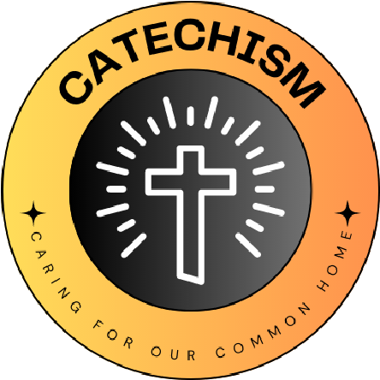

L
I
V
I
N
G

L
A
U
D
A
T
O

S
I
C
A
R
I
N
G

F
O
R

O
U
R

C
O
M
M
O
N

H
O
M
E
School name
The quote we have chosen is...
May we always praise you for all your beauty in creation.

We have chosen this because..... It is part of a prayer that was written, in recognition of Saint Francis of Assisi, the patron saint of the environment.
What Missions and Sub-missions have you chosen and how does your 'why' link to this?
Nature: We chose this because we want to improve the natural environment of the school by increasing pondlife, planting trees and starting to compost waste from our school kitchen.
Energy: We chose this mission because we made good progress last academic year, thanks to the support of the school’s Premises Officer, and we wish to continue by having two ‘walk to school days’ in the Lent and Pentecost terms.
Water: We want to further develop the pond area and get water butts in the school grounds to provide natural water for plants. We want to continue with recycling plastic, following the visit from SW Leicestershire Wombles last academic year that showed us how long it takes for plastic to decompose.

Our 'why' for the year
St. Peter’s, Earl Shilton

