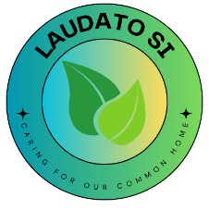

ST JOSEPH’S ECO CODE
2024 - 2025
Our Eco Code shows us to be…
RESPONSIBLE – YOU gave us responsibility to care for the earth and our own actions.
EARTH – YOU created the earth for us to share with its beauty and plenty.
SUSTAINABILITY – WE all need a desire to live simply.
PEACEFUL – YOU gave us the ability to change our ways that will help your earth.
ENVIRONMENT – YOU allow us to enjoy the delights and beauty of your creation.
COMPASSION – YOU are a loving and compassionate God who created the world to share.

TOGETHER – WE must act in solidarity to make a change and make a change as our beautiful earth can not be lost.

THERE IS ONLY ONE WORLD FOR US TO SHARE SO
RESPECT IT!

