


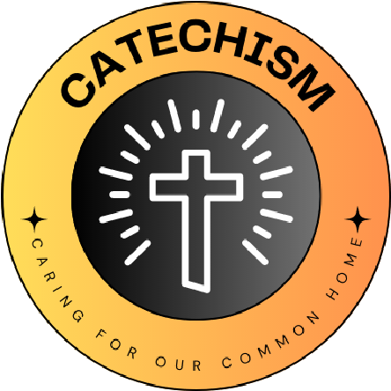

L
I
V
I
N
G

L
A
U
D
A
T
O

S
I
C
A
R
I
N
G

F
O
R

O
U
R

C
O
M
M
O
N

H
O
M
E

Sacee
School name
The quote we have chosen is...

We have chosen this because.....
What Missions and Sub-missions have you chosen and how does your 'why' link to this?
Our 'why' for the year
Energy – Regular monitoring: This regular monitoring links to our ‘why’ mission because we will be encouraging people to use less energy, helping to sustain the world’s natural resources.
Nature – Gardening club: This club links to our ‘why’ mission, as we will be nurturing and preserving God’s creation and allowing nature to thrive.
Travel – Termly travel week: These travel weeks link to our ‘why’ mission, as we will be encouraging others to reduce the pollution in the local atmosphere.

God created the world. He allows us to live on his creation, and provides us with life, shelter, food, water and oxygen. We must be grateful and respect the planet in return – it is our duty to nurture, protect and preserve God’s wonderful creation. As an eco-team, this is what we aim to do.
“The Earth sustains humanity. It must not be injured; it must not be destroyed”.
St Hildegard of Bingen
Sacred Heart, Loughborough

