




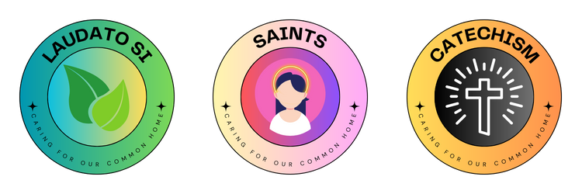

ECO
U
D
O
A
F
G
T
N
I
O
S
I
E
M
O
I
H
N
N
O
G
M
L
OUR ‘WHY’
A

R
U
O
R
R
A
C
L
I
V
M
O
C

School name:
Holy Cross Whitwick

The quote we’ve chosen is: We’ve chosen this because:
The environment is God's gift to
everyone, and in our use of it we
have a responsibility towards the
poor, towards future generations
and towards humanity as a whole.'
Pope Emeritus Benedict XVI

We think this is an important quote because it reminds us that the way that we treat world affects others. We have a duty to the planet and our global neighbours.

These are our Eco Missions and how they link to our why:
Waste – If we are careful with our waste, we will have a clean and healthy environment for both humans and animals to enjoy and live in.
Water – If we are not wasting water, we hope there will be more to go around and give to others who need it.
Transport – If less people are using their cars and producing green house gases, we hope that we can help to slow down the effects of climate change and help our future generations.

