
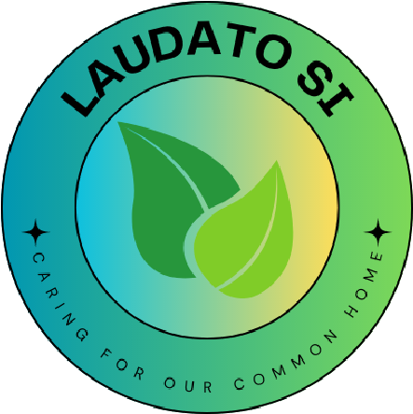
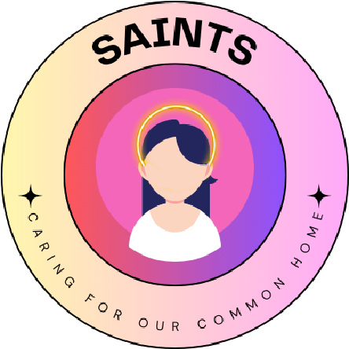
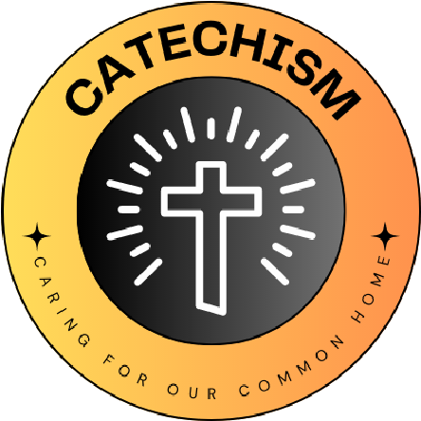

We are going to be working on the ‘Global Action’ sub-mission from the ‘Food’ mission, the ‘Wildlife habitats’ sub-mission from the ‘Nature’ mission and the ‘Recycling facilities’ from the ‘Waste’ mission
We will be collecting money for CAFOD throughout the year and gifting food-specific projects to families and communities around the world who are in desperate need of help. This links directly to our ‘Why?’ statement of helping others by giving to charity.
Our ‘wildlife habitats’ and ‘recycling’ sub-missions come at the ‘Why?’ statement from a different angle, and focus on the natural world and also about educating our school community about the need to look after our world so that we can ‘give’ it to generations to come.
Remember that the person who plants few seeds will have a small crop; the one who plants many seeds will have a large crop. You should each give, then, as you have decided, not with regret or out of a sense of duty; for God loves the one who gives gladly.
2 Corinthians 9:6-15

St Winefrides Catholic Voluntary Academy
Our Eco-team loved the fact that this scripture reflects the nature of giving. We liked the idea that we give because we want to and we know it is the right thing to do, and that this generosity is both required and rewarded by faith.
L
I
V
I
N
G

L
A
U
D
A
T
O

S
I
C
A
R
I
N
G

F
O
R

O
U
R

C
O
M
M
O
N

H
O
M
E
School name
The quote we have chosen is...

We have chosen this because.....
What Missions and Sub-missions have you chosen and how does your 'why' link to this?
Our 'why' for the year

