UNIFORM Exchange- Waste
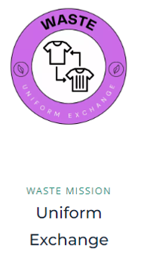
Our Uniform Exchange Stalls- We asked for donations of old uniform and put out stalls in the playground offering these items free of charge. This was a very successful event, and our parents were very grateful. There were many that accessed the sale and thanked us for the opportunity.
The last remaining items will be available for parents again tomorrow morning.
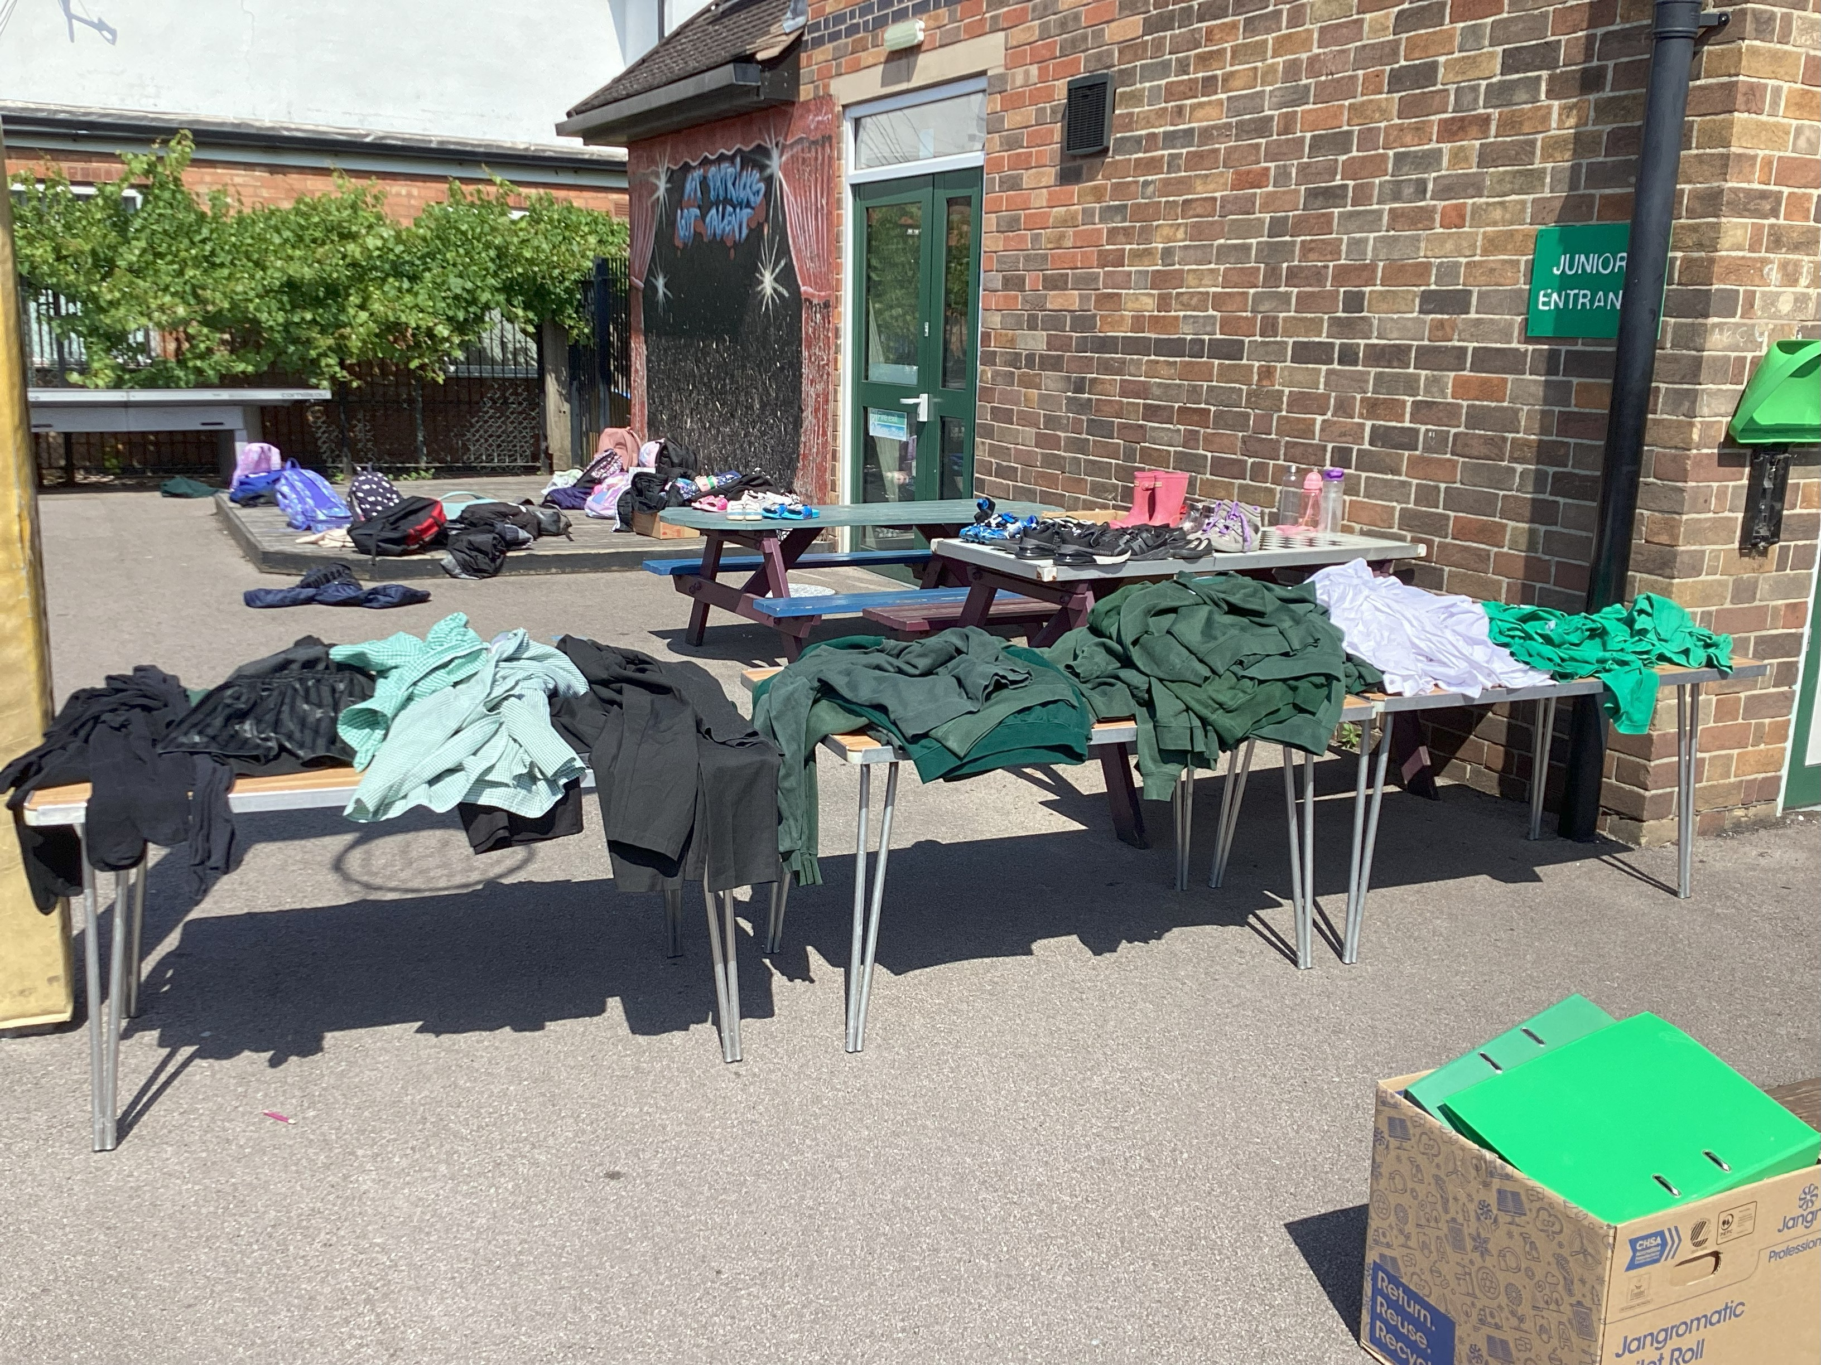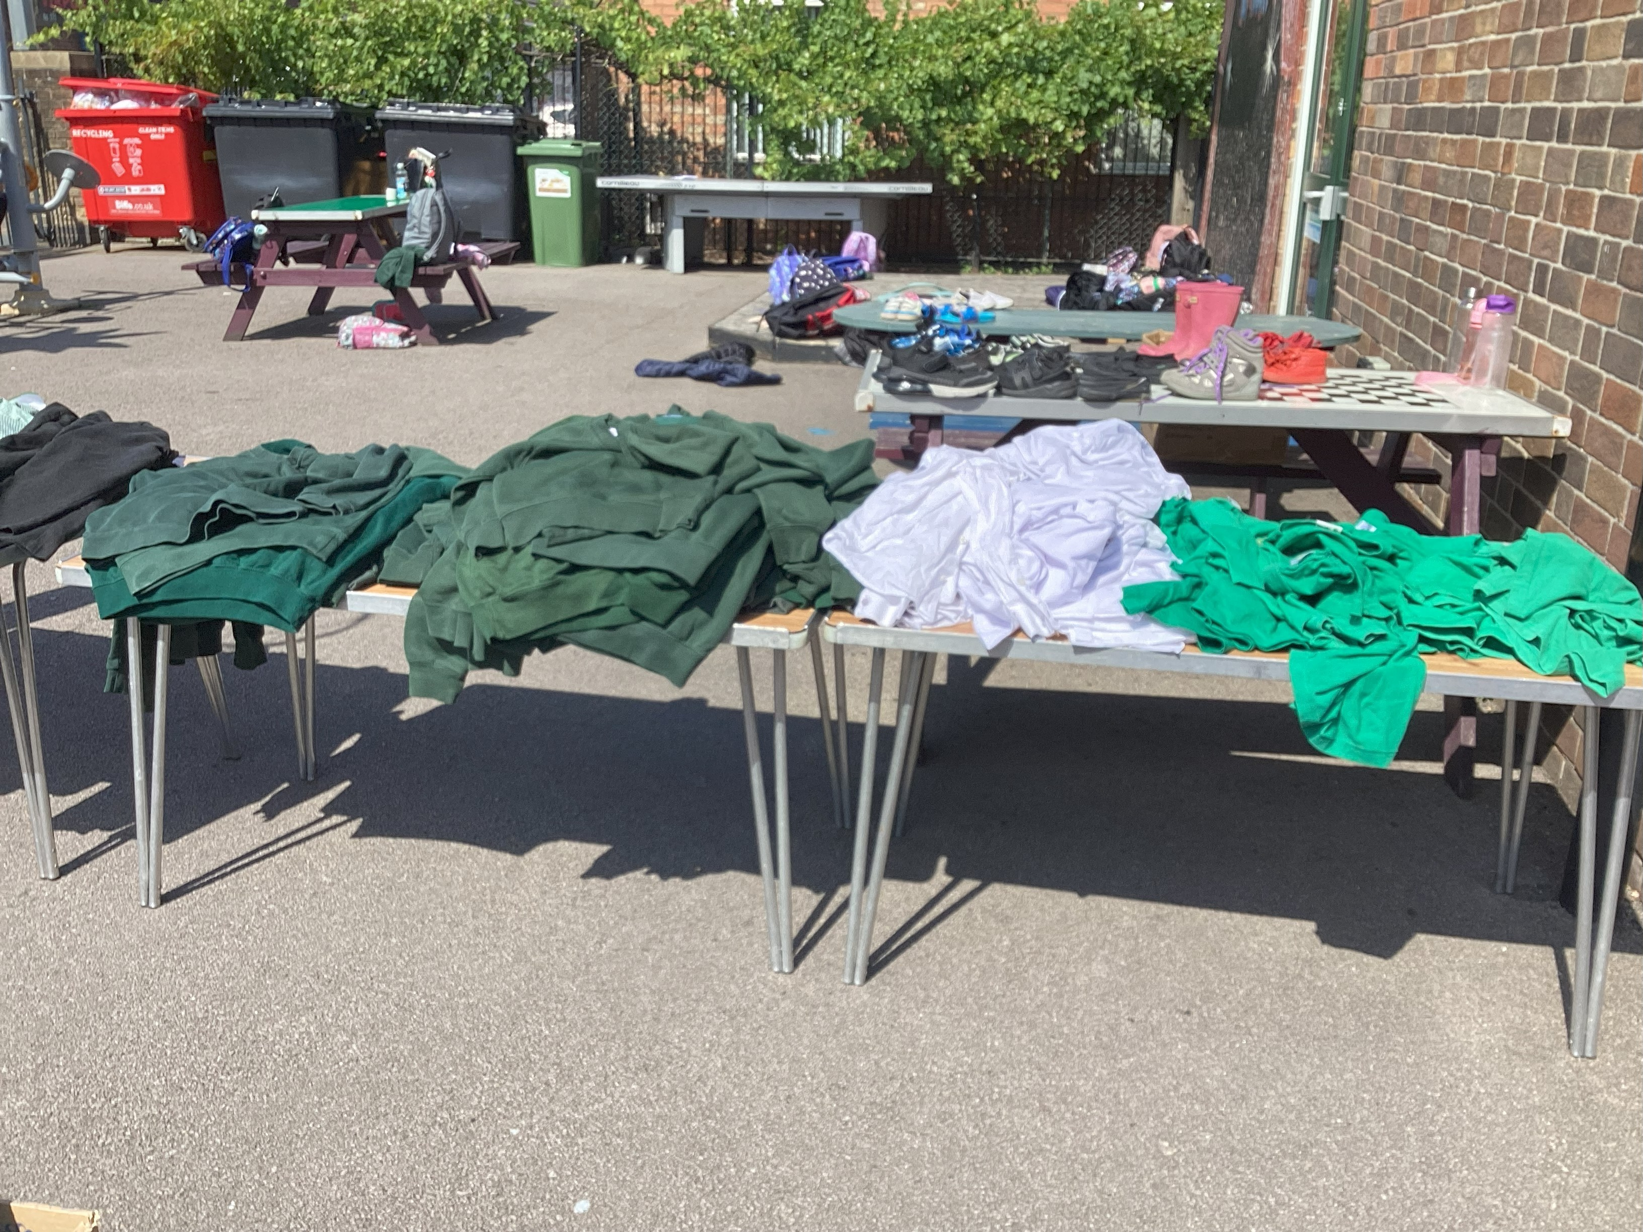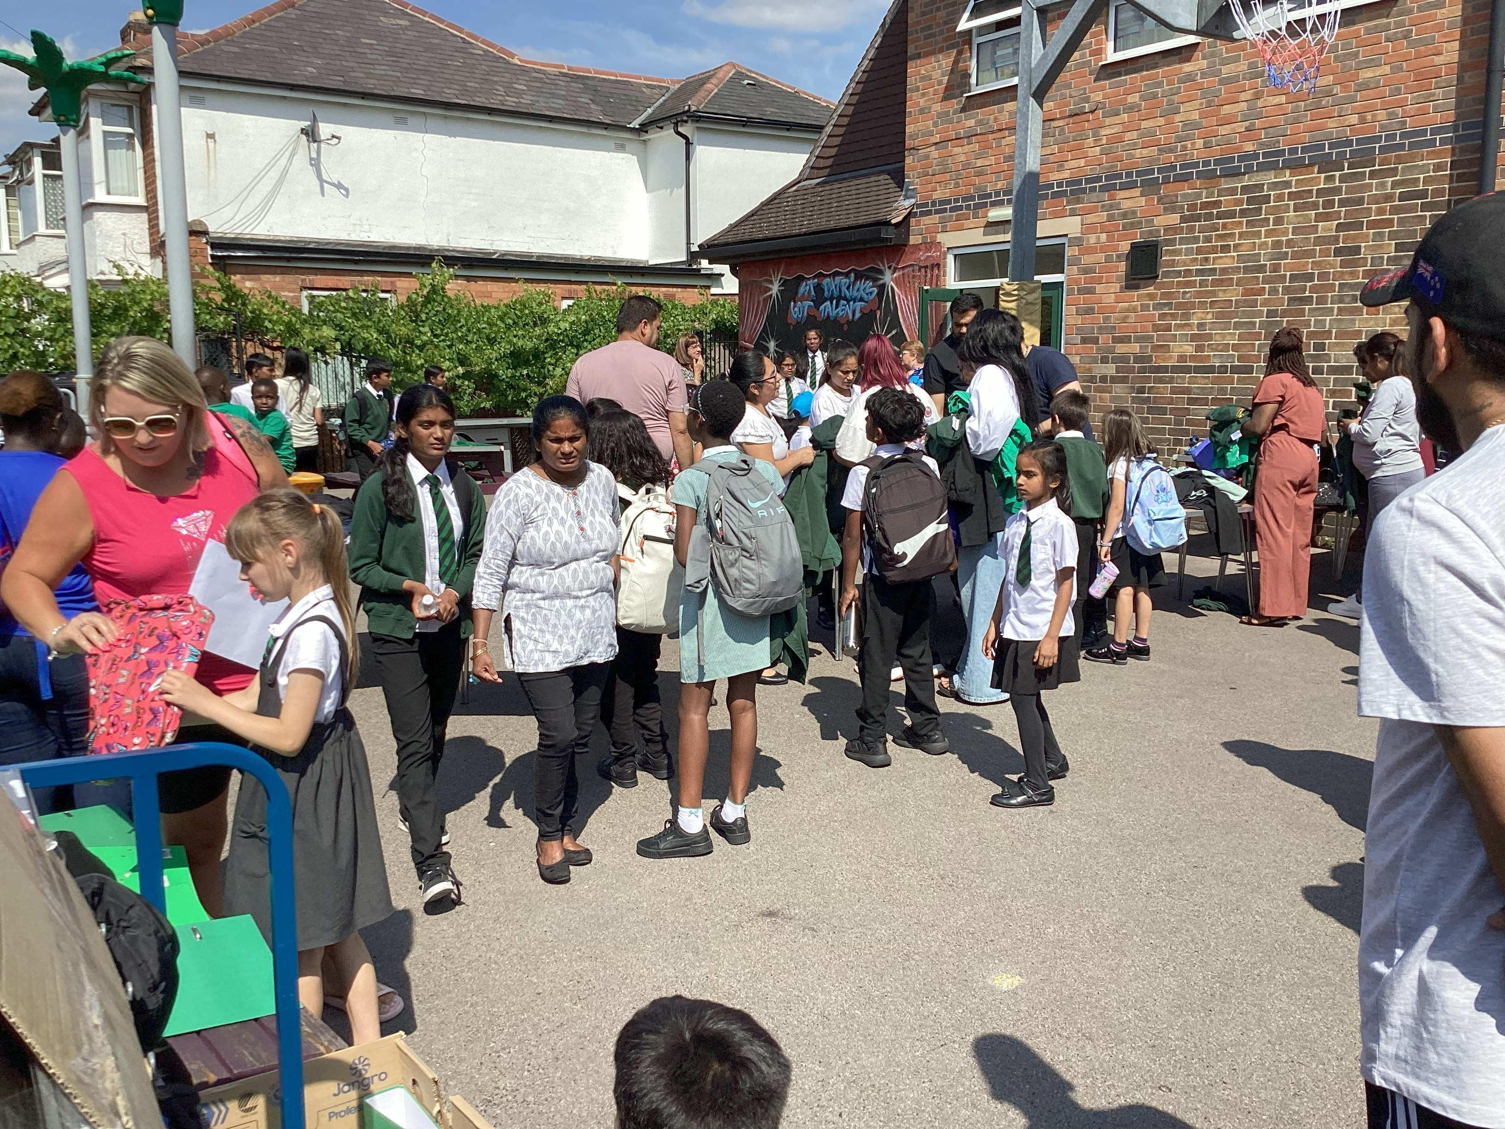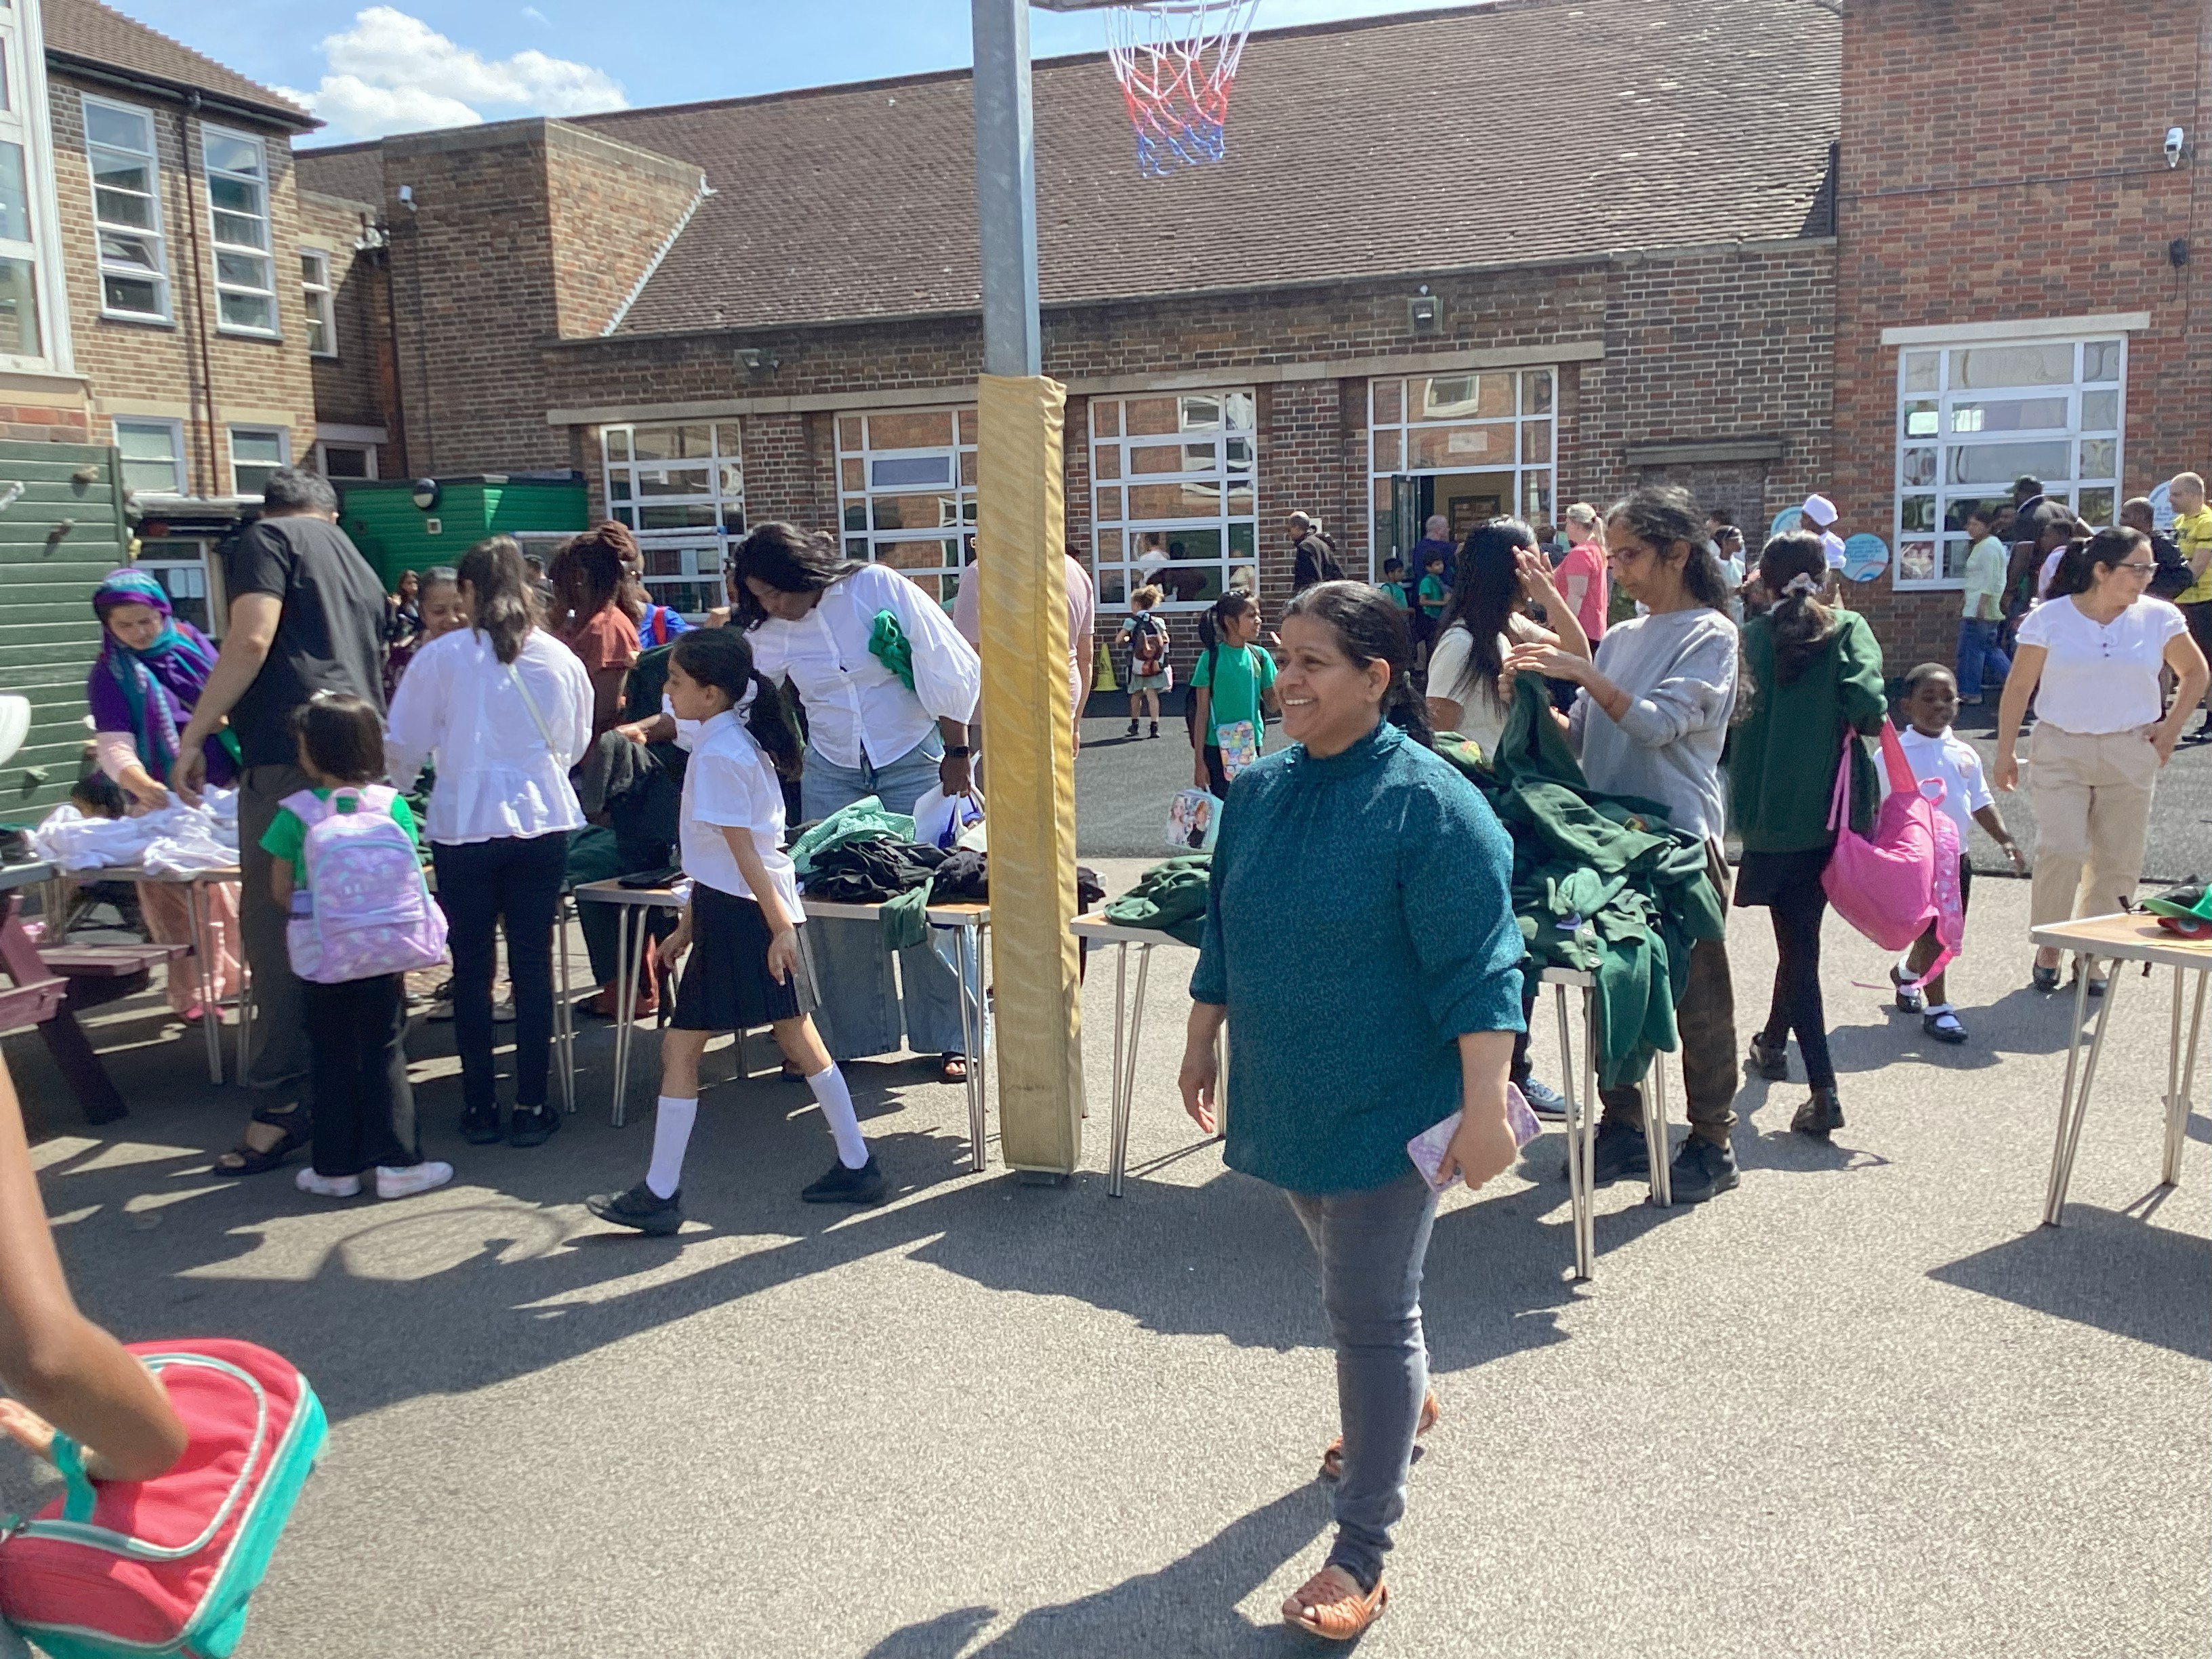
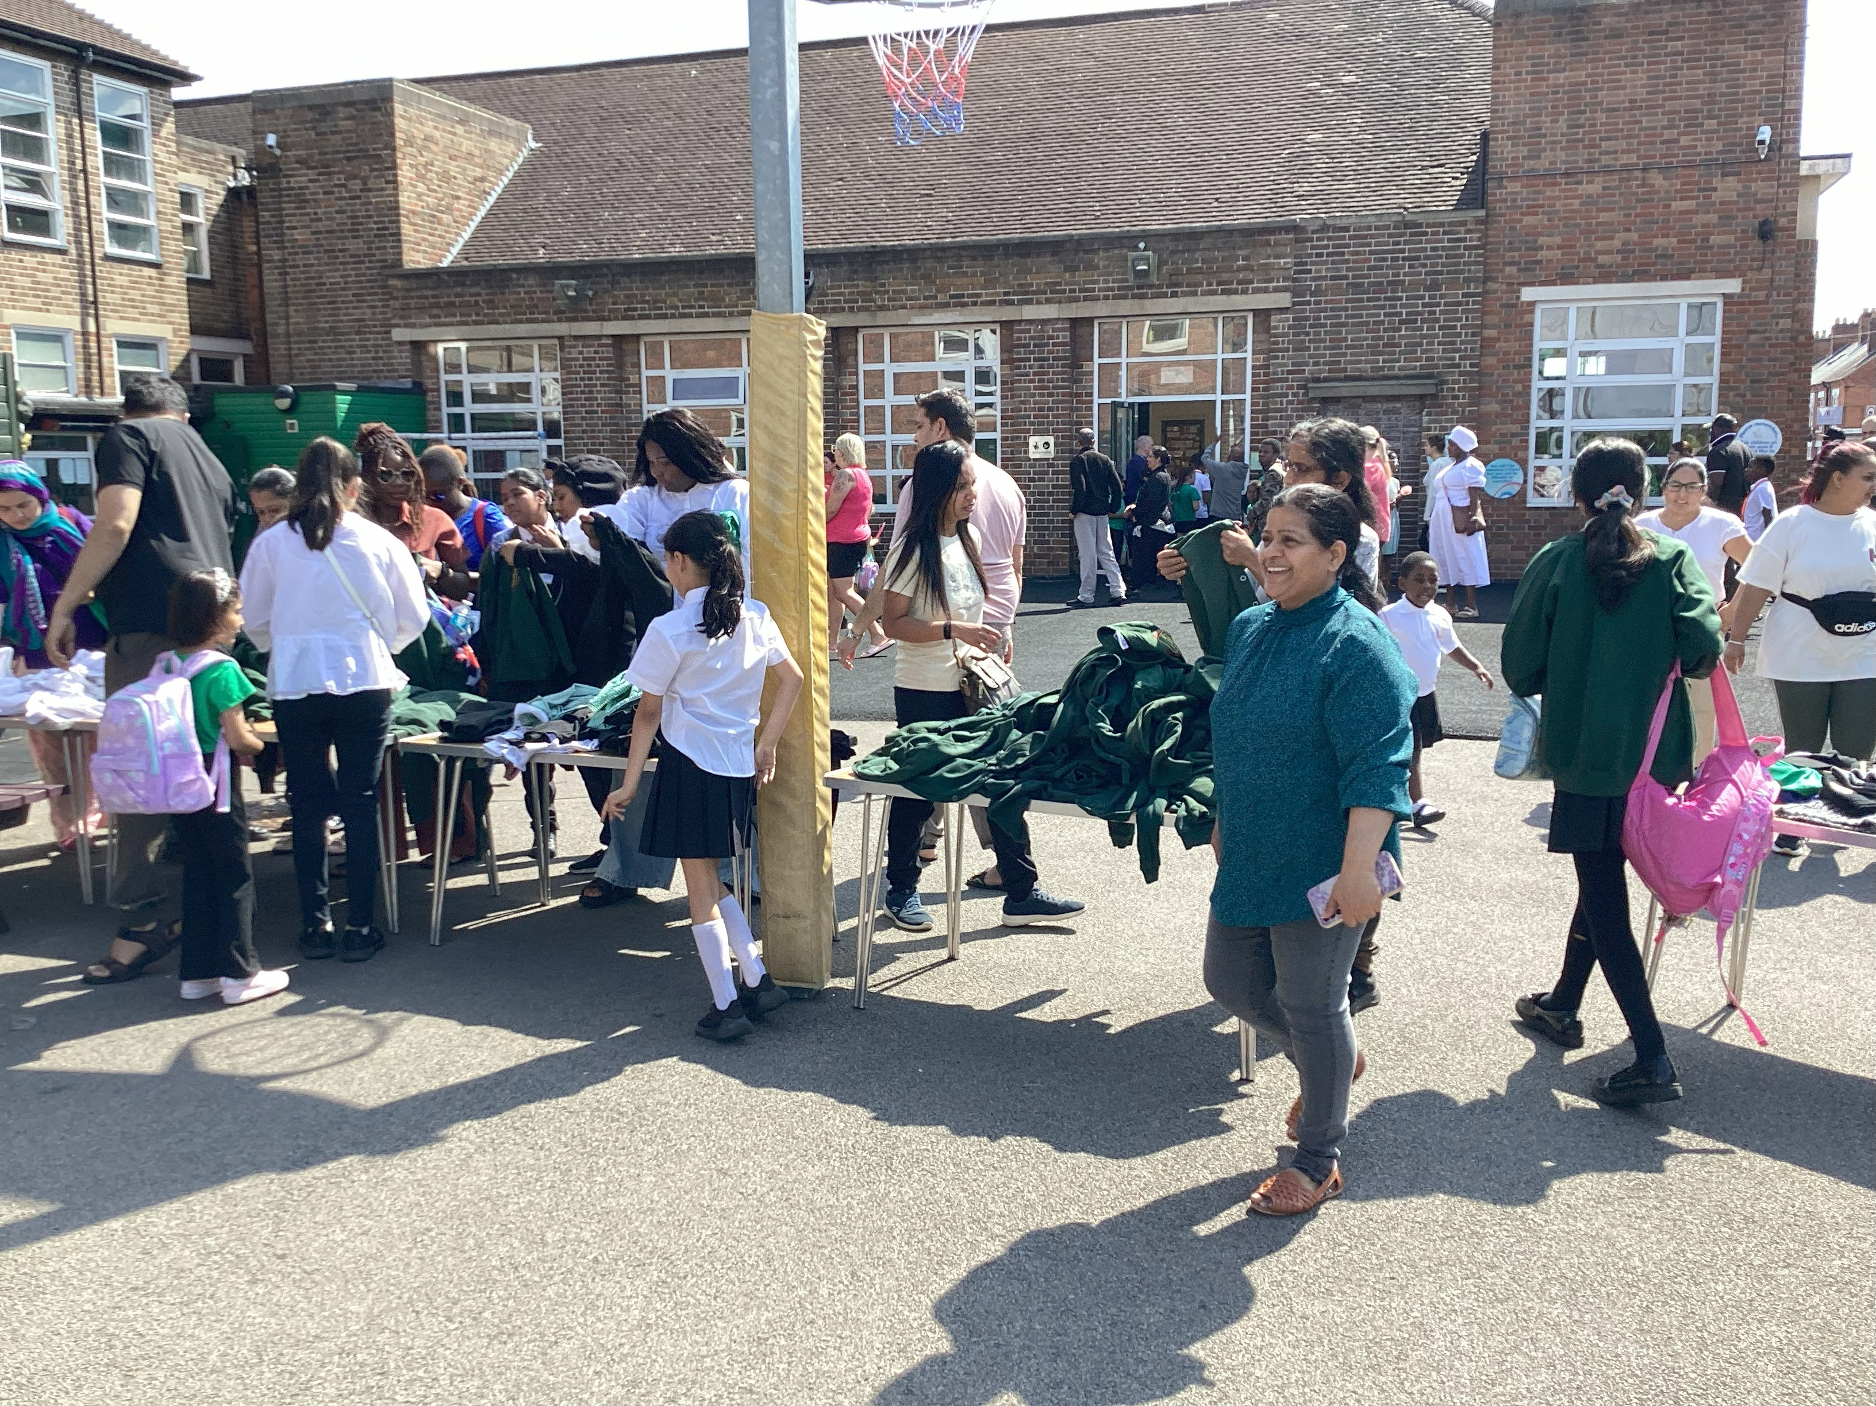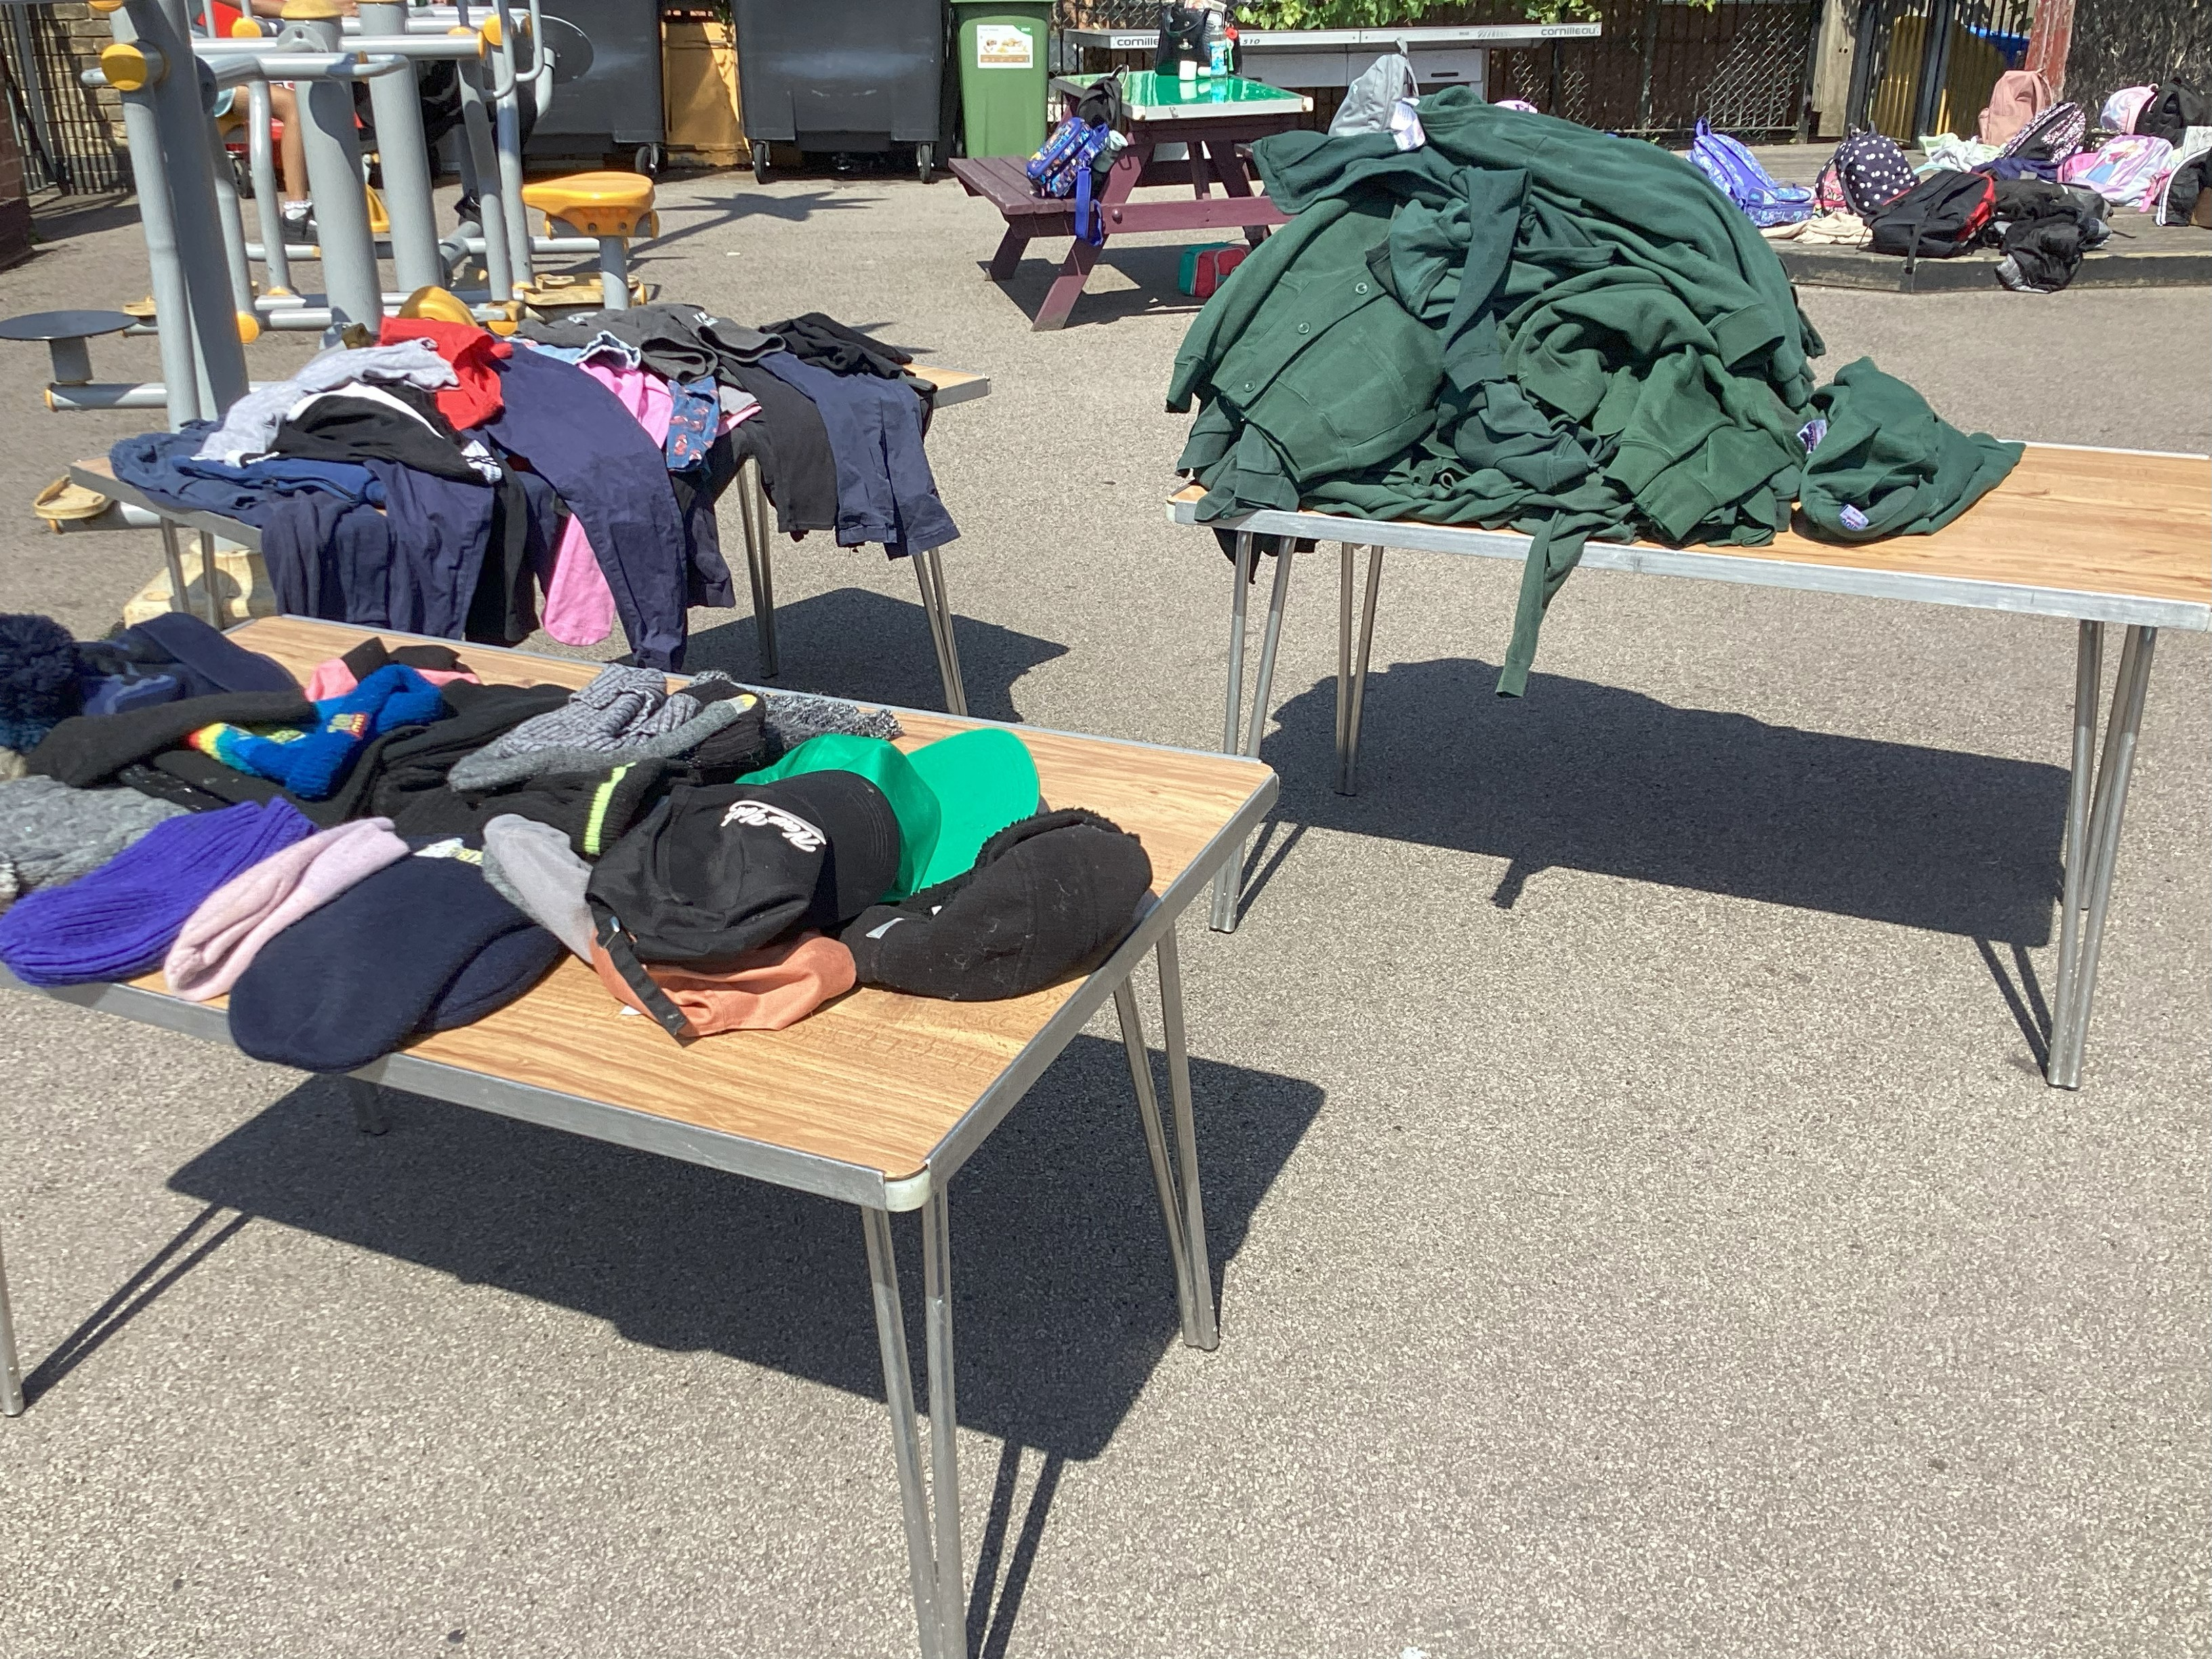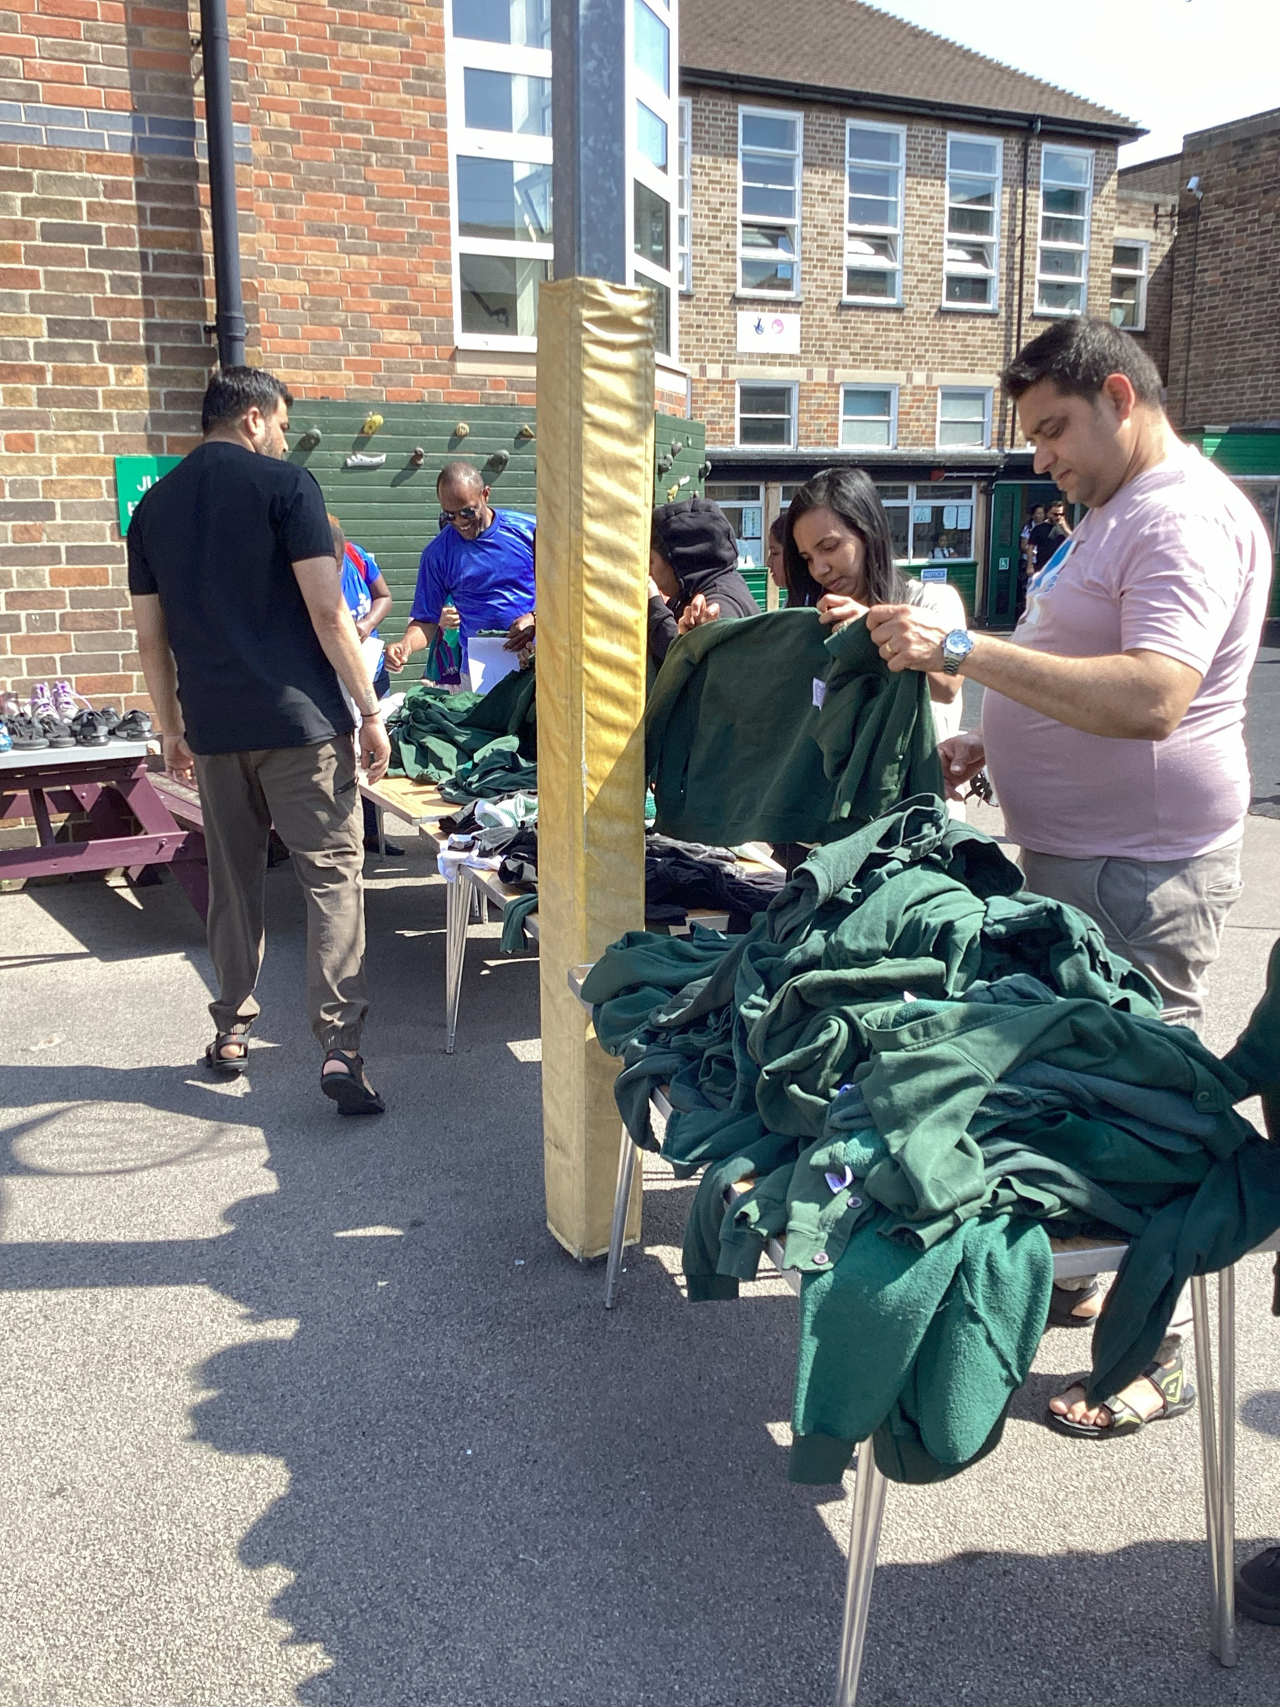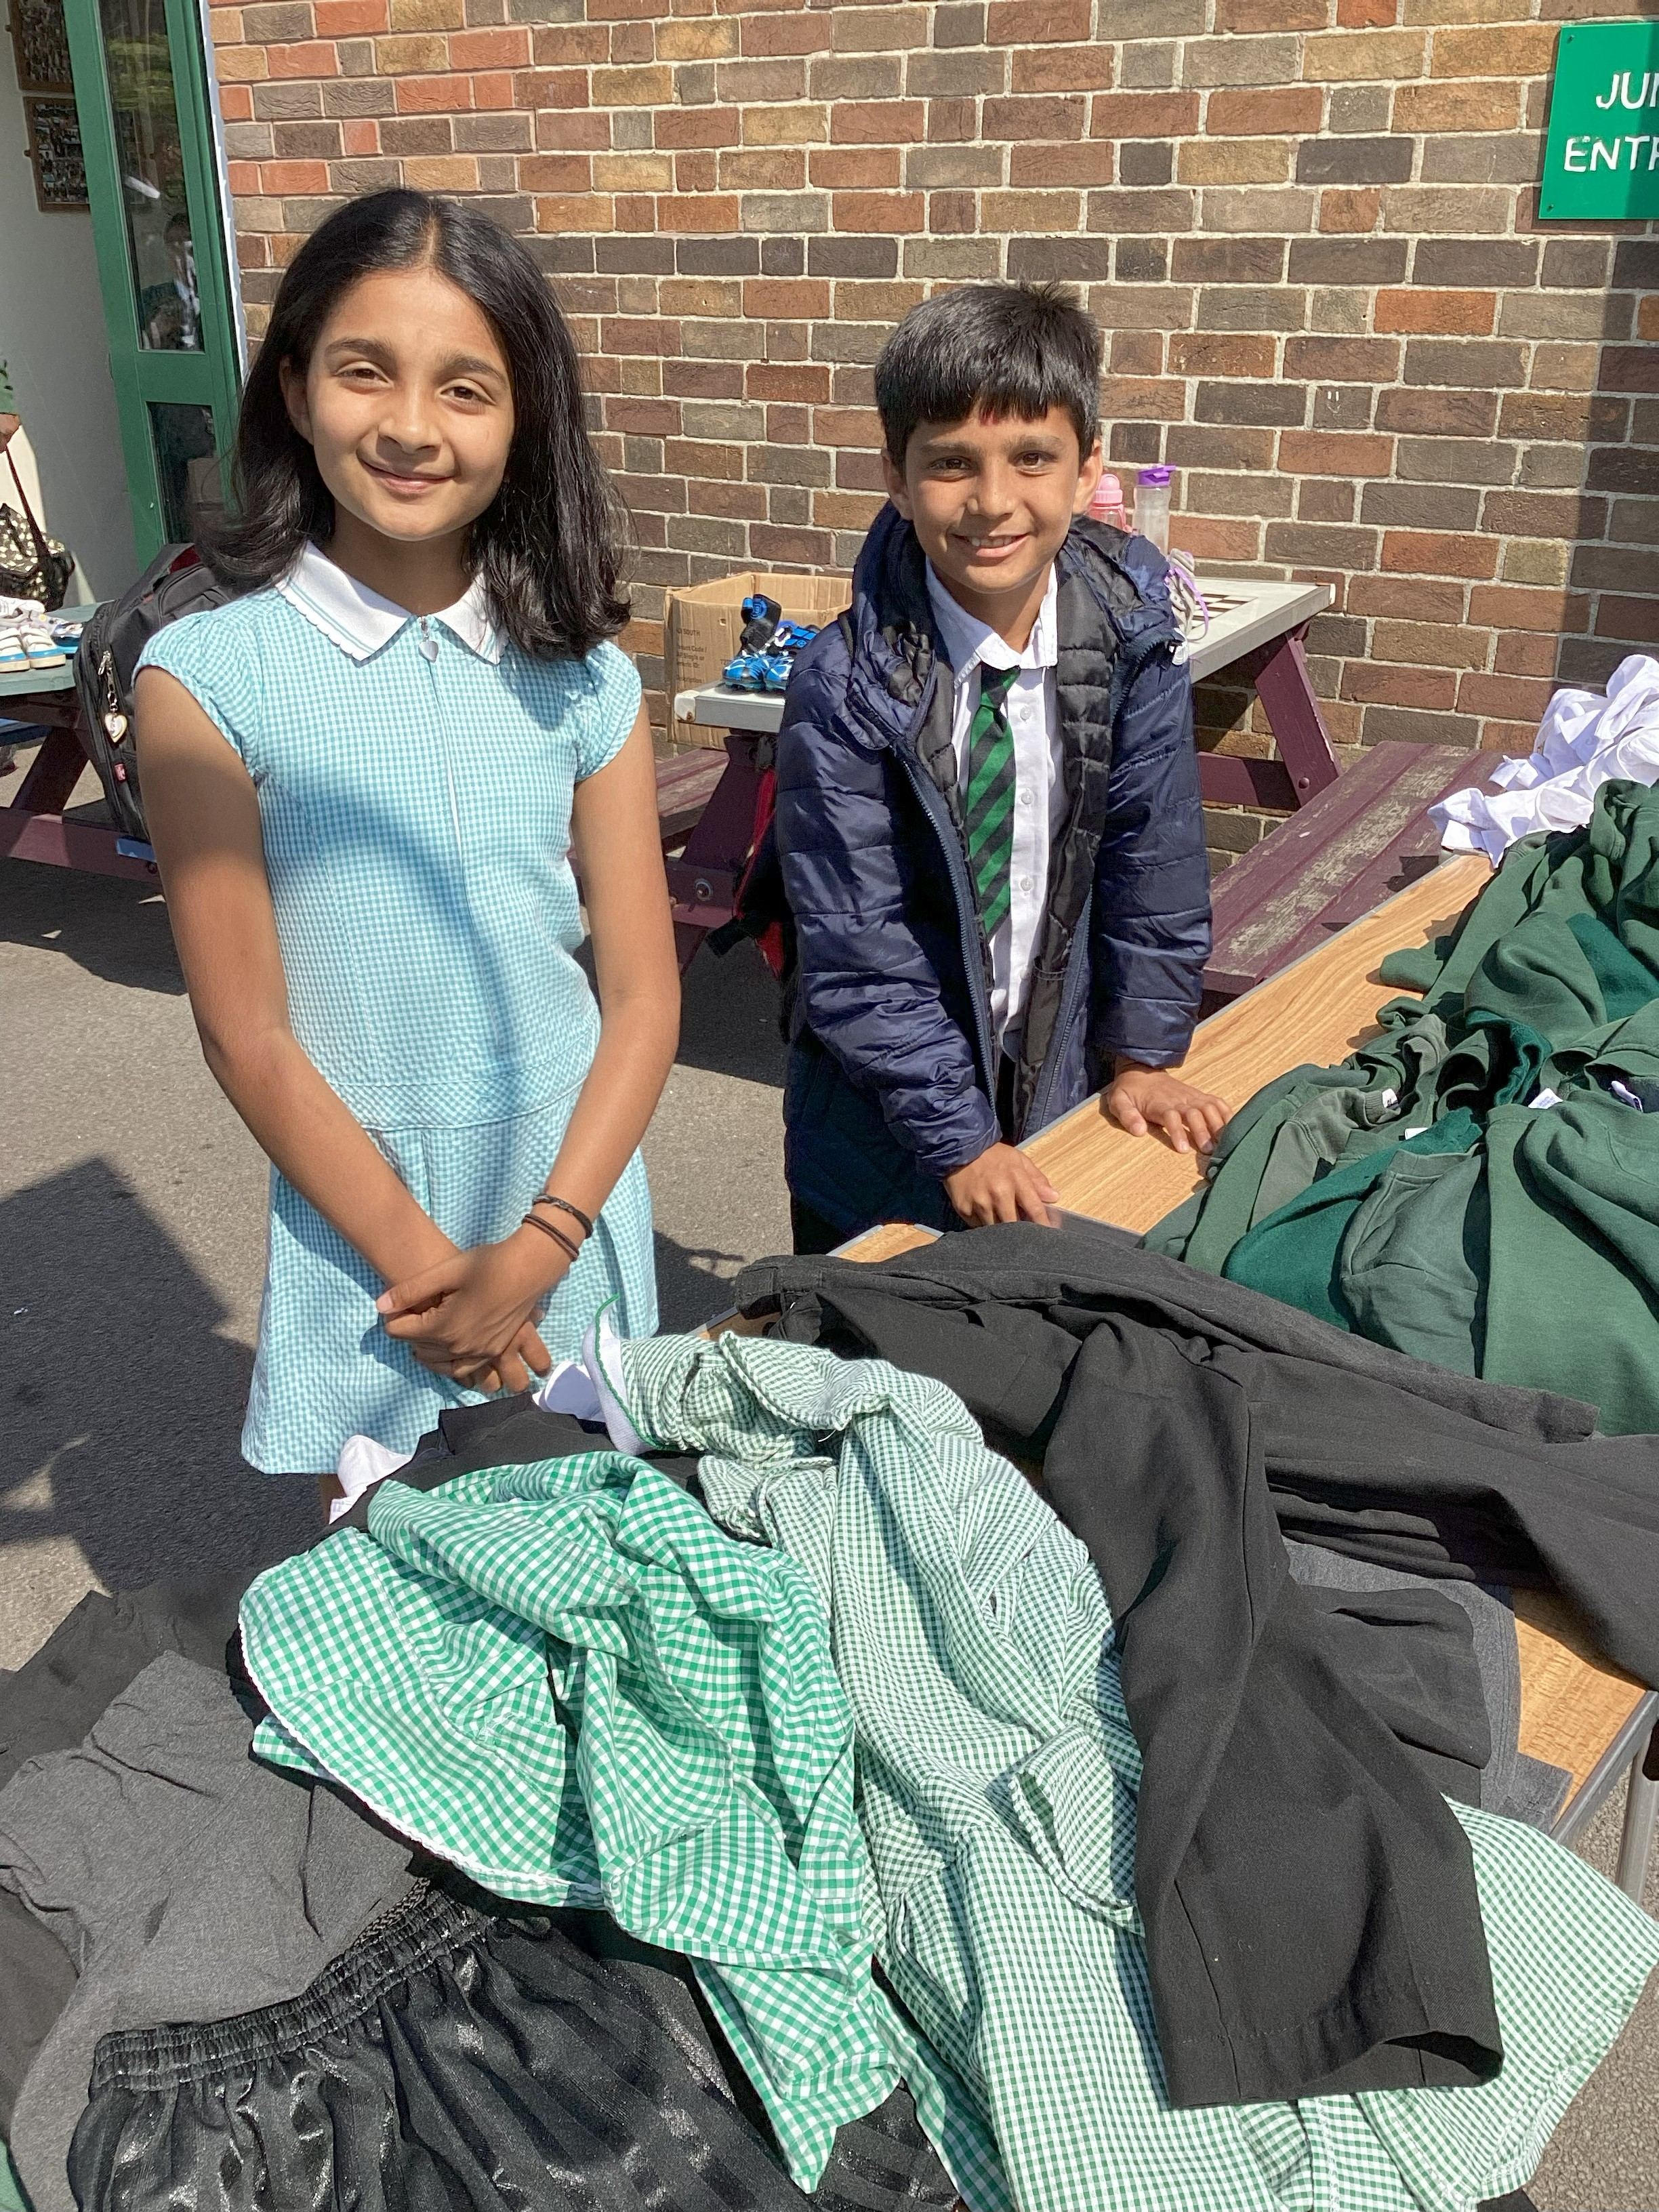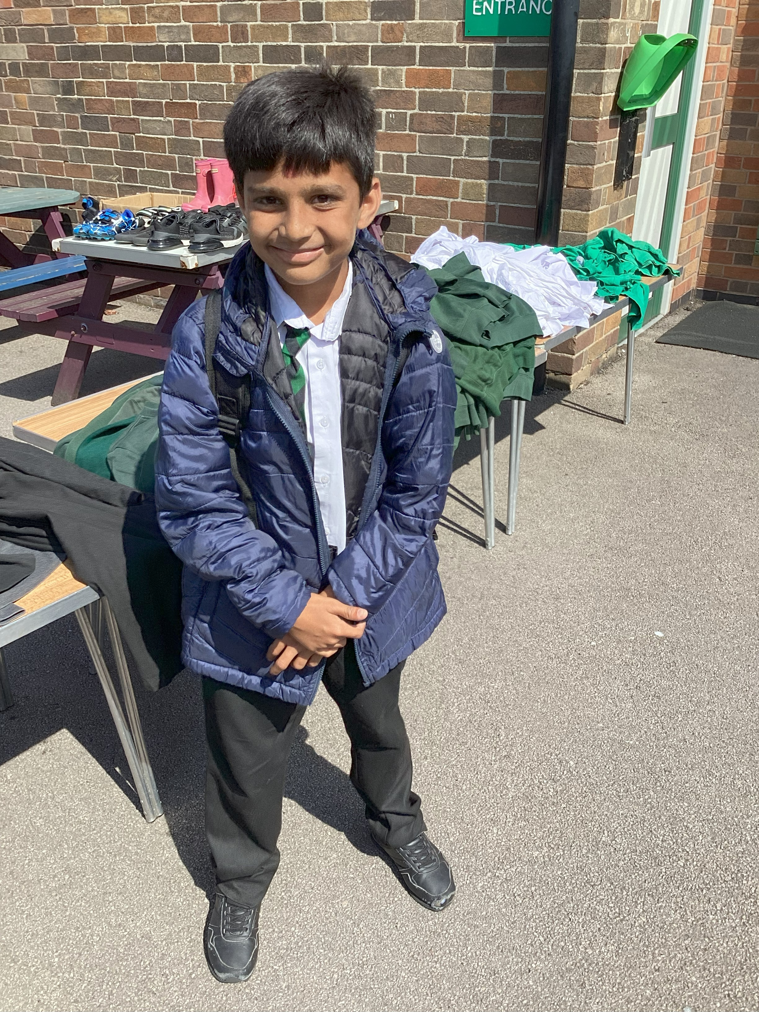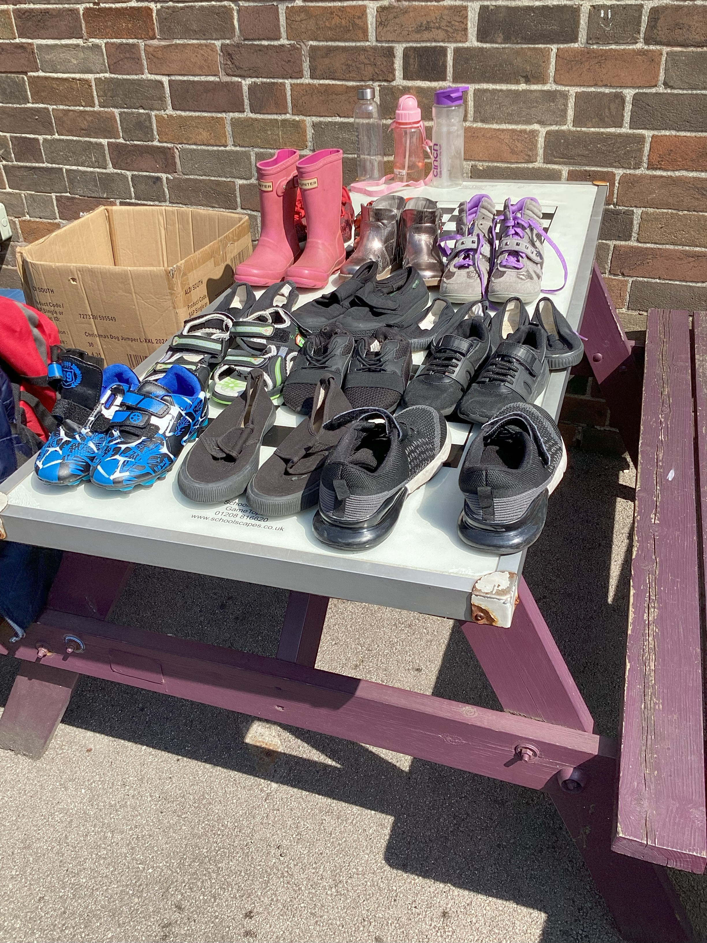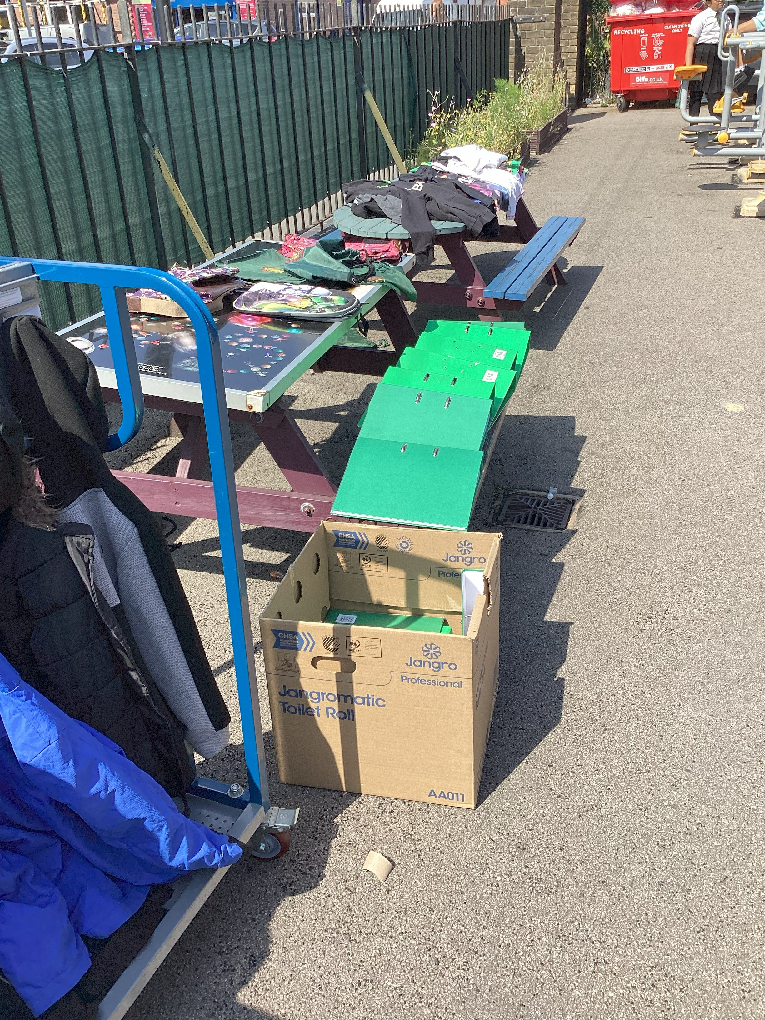

Parents DOJO messages

Mrs. Agbanusi
St Patrick's Primary School
2 hours ago
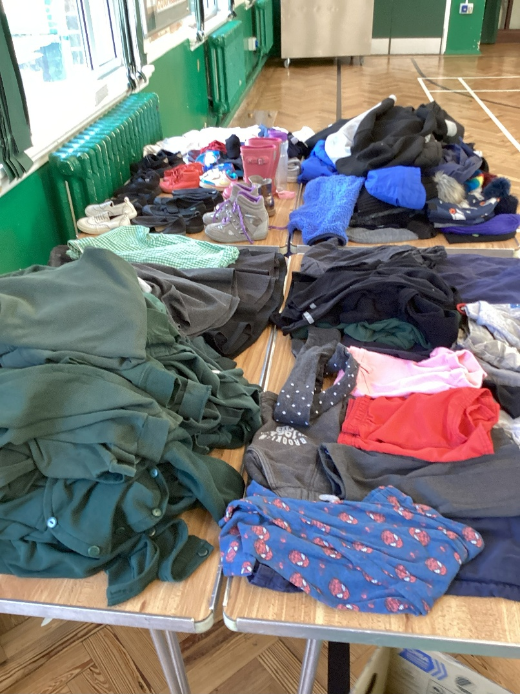

We will be leaving what’s left of our donations of uniform, cardigans, shirts, shorts, shoes and paper folders outside in the playground before school tomorrow morning. All items are free so please take as many items as you need.
Thank you to everyone who has donated.
Another big thank you to our eco team here at St Patrick’s for organising this successful event.
Translation viewed by 5 parents
5 likes 77 views LikeComment

Mrs. Agbanusi
St Patrick's Primary School
7 Jul
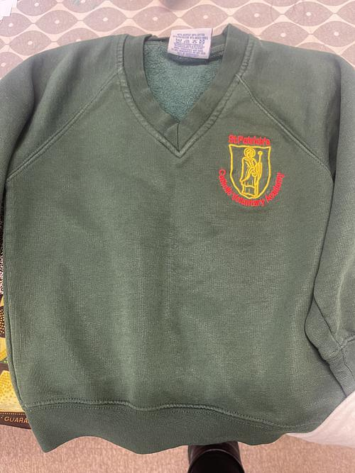
PRE LOVED UNIFORM TABLE-Ran by our Eco Team
After school on Wednesday there will be a variety of pre loved uniform on display in the Key Stage 2 playground. Please help yourself to any items that you may need. These are free of charge.
If you have any washed and unnamed uniform items that you wish to donate, please can you hand these into the school office before Wednesday this week.
Many thanks
THE ECO TEAM & Mrs Agbanusi & Mr Rabjohn
Translation viewed by 13 parents
9 likes
209 views
LikeComment

