
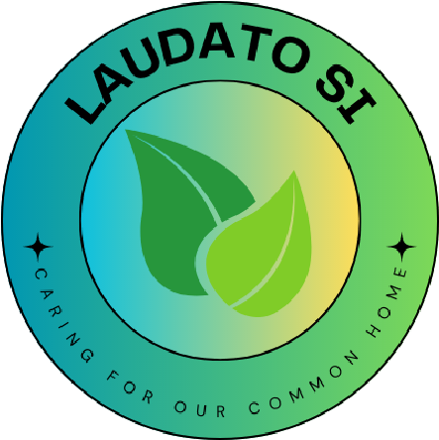
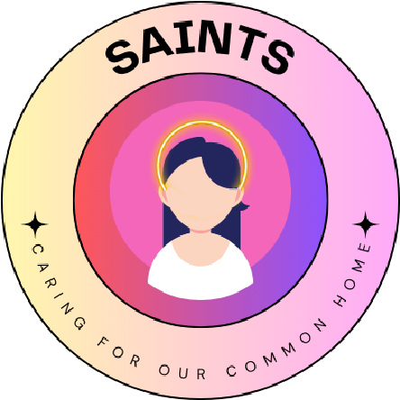
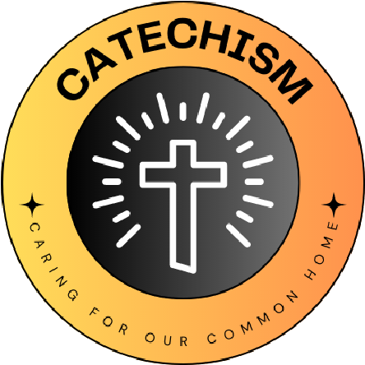

L
I
V
I
N
G

L
A
U
D
A
T
O

S
I
C
A
R
I
N
G

F
O
R

O
U
R

C
O
M
M
O
N

H
O
M
E
SSS
School name
The quote we have chosen is... “Because all creatures are connected, each must be cherished with love and respect, for all of us as living creatures are dependent on one another.” Paragraph 42 Laudato Si

We have chosen this because.....
We should treat people as we would want to be treated
A good idea because it says to save the environment, so our planet doesn’t die
Respect God’s planet and the animals in ways that we would want to be treated
Respect people, love one another
Shows all people should respect one another and that means we should respect God’s creation
We chose this because one day a child may ask ‘What is a lion?’

What Missions and Sub-missions have you chosen and how does your 'why' link to this?
WASTE – reduce Plastic
ENERGY – switch off campaign
FOOD – Food bank

Our 'why' for the year
St Paul’s Catholic School

