


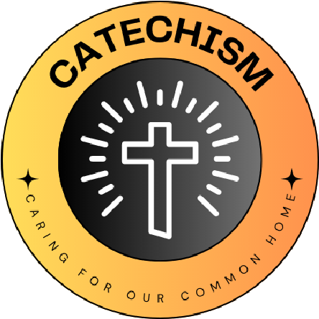

L
I
V
I
N
G

L
A
U
D
A
T
O

S
I
C
A
R
I
N
G

F
O
R

O
U
R

C
O
M
M
O
N

H
O
M
E
S
School name
St Josephs Leicester

The quote we have chosen is...
CCC 2457 Animals are entrusted to man's stewardship; he must show them kindness. Our actions impact of the habitats and lives of the animals in our world. We need to think about how we can show animals kindness through our choice of food and how we look after the biodiversity of the planet.
From Catechism of the Catholic Church

We have chosen this because...
The eco team are concerned about the way the world climate is changing. With recent localised flooding, they wanted to ensure that they could protect local wildlife, habitats and to continue to grow the biodiversity of the school grounds.

What Missions and Sub-missions have you chosen and how does your 'why' link to this?
The eco team have decided to concentrate on the Nature Mission. They want to support the natural world and make our school and wider community a better place for plants, insects, and animals.

We run a gardening club giving the children the opportunity to explore growing their own vegetables and seeing how they go from seed to plate.

Another sub mission we will be working towards is wildlife habitats. We will be building and installing hedgehog and bird boxes. Continuing work on our bug hotel.

Our 'why' for the year

