
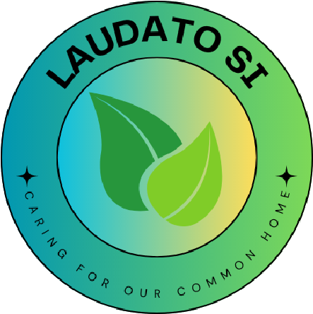

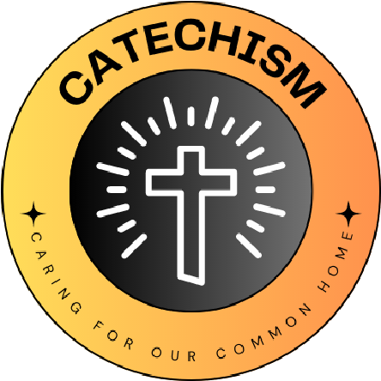

L
I
V
I
N
G

L
A
U
D
A
T
O

S
I
C
A
R
I
N
G

F
O
R

O
U
R

C
O
M
M
O
N

H
O
M
E
School name
Saint Patrick’s Catholic Voluntary Academy

The quote we have chosen is...
St Francis of Assisi:
“Start by doing what’s necessary; then do what’s possible; and suddenly you are doing the impossible.”

We have chosen this because....
“We want to start with small steps that we CAN do and build on these to eventually do what we now think are not possible.”
“Anything can be possible if we work together and try our best.”
“Every journey starts with one small step”.
What Missions and Sub-missions have you chosen and how does your 'why' link to this?
Food – we are going to set up our own school foodbank to support our school family. We will ask parents to provide food, try and and make community links to local shops to provide food close to sell by dates. We realise that some of our school families do not have as much as others. As a whole school family, we can help our individual families. This links we think to St Francis’ words of what’s necessary across our school.
Energy – Students act as energy monitors in school making sure lights are turned off in rooms and projectors are not left on when needed. We will run green competitions throughout the year to help encourage changes in our behaviour. This links to our why as we see it as a small step on our green journey.
Waste – We will set up a uniform swap shop for us (eco team) to run. This will offer our families the chance to prevent waste of old uniform and help families save money buying new uniform. We feel this fits nicely with St Francis’ words of necessary and possible for us to make a start and set an example on how to recycle and that it’s possible for everyone to do this.
Waste- As an addition we will be out in our local community picking up and recycling litter.
We feel this is something that’s necessary and we feel is possible for us to contribute and help God’s world.

Our 'why' for the year

