


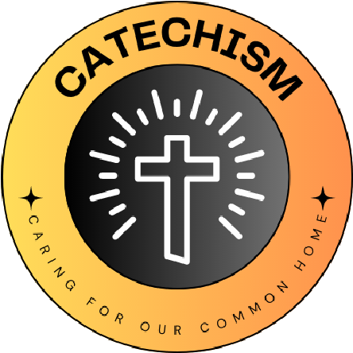

L
I
V
I
N
G

L
A
U
D
A
T
O

S
I
C
A
R
I
N
G

F
O
R

O
U
R

C
O
M
M
O
N

H
O
M
E
English Martyrs, Oakham

The quote we have chosen is... CCC 2402 ‘The goods of creation are destined for the whole human race.’ God made our world for all of us, so it needs to be taken care of so that we can all enjoy it.

We have chosen this because it was the quote which we felt was the most important and summed up out feelings and beliefs on stewardship of the environment.
What Missions and Sub-missions have you chosen and how does your 'why' link to this?
Energy: Switch off day once per term – this links to our why as it shows our commitment to taking care of the environment by making small changes in school.
Kitchen Garden - we will support classes and the kitchen to look after their vegetable boxes and the herb garden by the kitchen. Not only will this let us produce more home grown food it will hopefully help increase the biodiversity of the school site.
Yearly Travel Week – we will organise a week in the summer term where we will encourage as many people as possible to travel to and from school using sustainable transport.
Our 'why' for the year

