


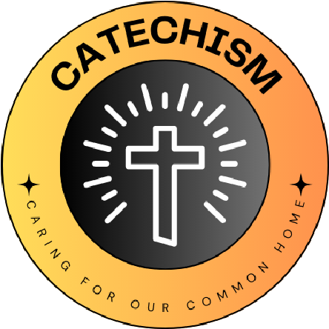

Energy:
- Switch off campaign: a ‘no energy’ Mass
- Regular monitoring: once a week
This links to our ‘why’ because we will be taking care of the creation by turning off lights and saving electricity.
Travel:
- Anti-idling campaign: monitor how many parents leave their engines running whilst waiting to pick of their children?
- Yearly travel week
This links to our ‘why’ because we will be using less gas which helps with our climate change crisis. God wants us to use the environment safely and care for it so doing the yearly travel week will help.
Waste:
- Litter picking: once a week
- Global actions: writing letters to MP’s, making posters for the local community about waste.
This links to our ‘why’ because reducing litter will help save the environment so that we are able to enjoy it. We can help communities change and look after the world by making posters and writing letters to MP’s.
- We should always take care of God’s creation: our world
- If we don’t take care of God’s creation, then we can’t enjoy the fruits within the world for us.
CCC 2402: ”The goods of creation are destined for the whole human race”
God made our world for all of us, so it needs to be taken care of so that we can all enjoy it.
St. Clare’s Primary School
L
I
V
I
N
G

L
A
U
D
A
T
O

S
I
C
A
R
I
N
G

F
O
R

O
U
R

C
O
M
M
O
N

H
O
M
E
School name
The quote we have chosen is...

We have chosen this because.....
What Missions and Sub-missions have you chosen and how does your 'why' link to this?
Our 'why' for the year

