
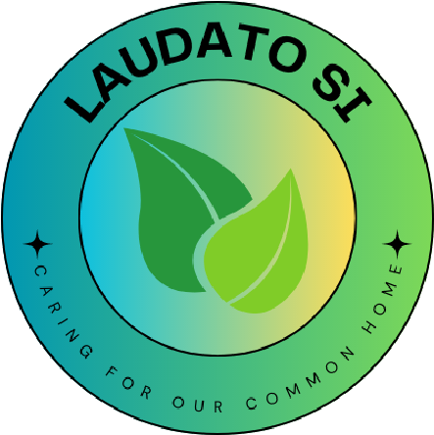

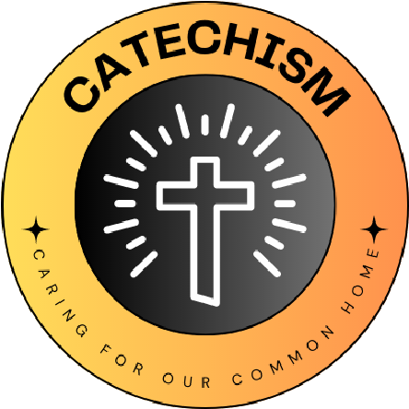
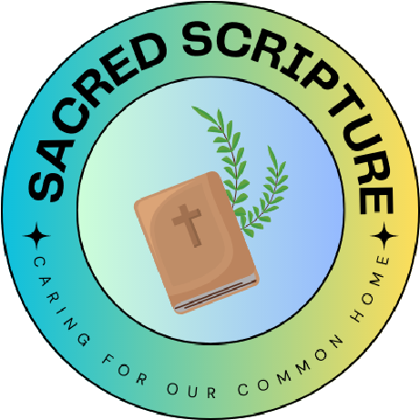
Nature – We will create more areas in our school grounds for wildlife. We will create more wildflower areas, will create bug hotels and will incorporate plants into our prayer garden.
Waste – We will teach the school community what can and can’t be recycled. We will regularly litter-pick and encourage others to use the correct bins. We will begin recycling writing instruments in each classroom.
Travel – We will encourage children and staff to choose sustainable means of travel to get to school. We will monitor this with the travel tracker and give out monthly rewards as an incentive.
We will also teach about Fair Trade and take part in the Fair Trade fortnight.
Laudato Si’ is a letter from Pope Francis to everyone on the planet urging all of us to protect the earth; our common home. The earth is God's gift to us, full of beauty and wonder, where the fruits of the earth belong to everyone. We are called to protect it as ‘living our vocation to be protectors of God’s handiwork is essential to a life of virtue’.
‘We have a shared responsibility for others and the world, and that being good and decent are worth it’
- Laudato Si’
Holy Cross Catholic Primary Leicester
L
I
V
I
N
G

L
A
U
D
A
T
O

S
I
C
A
R
I
N
G

F
O
R

O
U
R

C
O
M
M
O
N

H
O
M
E
School name
The quote we have chosen is...

We have chosen this because.....
What Missions and Sub-missions have you chosen and how does your 'why' link to this?
Our 'why' for the year

