


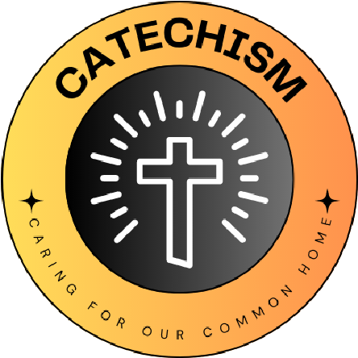

L
I
V
I
N
G

L
A
U
D
A
T
O

S
I
C
A
R
I
N
G

F
O
R

O
U
R

C
O
M
M
O
N

H
O
M
E
Sa
School name
Sacred Heart, Leicester
From Laudato Si:
“Because all creatures are connected, each must
be cherished with love and respect, for all of us
as living creatures are dependent on one another”
Paragraph 42
The quote we have chosen is...
From Laudato Si:
“Because all creatures are connected, each must be cherished with love and respect, for all of us
as living creatures are dependent on one another”
Paragraph 42

We have chosen this because.....
We loved the use of the word ‘cherished’. It reflects the belief of our school completely.
We discussed what cherishing all living creatures would look like and felt that this really reflected our sense of Eco mission.
What Missions and Sub-missions have you chosen and how does your 'why' link to this?
Energy
- Switch off once a term. We felt as a group that we are too reliant on ‘screentime’ and that having a day once every time might make people realise that it is possible to teach and learn without a screen.
- Switch off. This was an area we started last year but would like to re-visit. The children felt that saving money and ultimately helping to save the planet was very important to our mission to cherish living things.
Nature
- Gardening club and litter picking. Our site is very urban, and we don’t have the lovely green fields that some schools have. We are very conscious that we need to make the area we have look as beautiful as we possibly can.
Our 'why' for the year

